**一、SOAPIn Axis2**

在前两天的教程中,我们学习到了用Axis2如何进行复杂数据、简单数据进行传输。

正如我在前一天教程中所说，在web service的世界里，一切都是基于SOAP的，因此在今天我们将学习Axis2中的SOAP特性。

今天的课程将用3个例子来完成即：

1）  客户端与服务端使用SOAP进行通讯

2）  服务端将Exception以SOAPFault的形式抛给客户端

3）  使用SWA（Soap With Attachment）来进行附件传送

**二、客户端与服务端使用SOAP进行通讯**

来看下面这个Web Service：

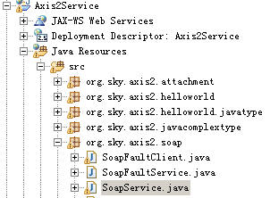

下面是Service端的源码

**org.sky.axis2.soap.SoapService**

|  |
| --- |
| package org.sky.axis2.soap;    import org.apache.axiom.om.OMAbstractFactory;  import org.apache.axiom.om.OMElement;  import org.apache.axiom.om.OMFactory;  import org.apache.axiom.om.OMNamespace;  import java.util.*;    public class SoapService {             public static OMElement requestSoap = null;             public OMElement request(OMElement soapBody) {                     requestSoap = soapBody;                       Iterator it = requestSoap.getChildElements();                     OMElement issuerElement = (OMElement) it.next();                     OMElement serialElement = (OMElement) it.next();                     OMElement revocationDateElement = (OMElement) it.next();                       String issuer = issuerElement.getText();                     String serial = serialElement.getText();                     String revocationDate = revocationDateElement.getText();                     System.out.println("issuer=====" + issuer);                     System.out.println("serial=====" + serial);                     System.out.println("revocationDate=====" + revocationDate);                     OMFactory soapFactory = OMAbstractFactory.getOMFactory();                     OMNamespace omNs = soapFactory.createOMNamespace(                                       "http://soap.axis2.sky.org", "");                     OMElement soapResponse = soapFactory.createOMElement("SoapResponse",                                       omNs);    **OMElement soapIssuer = soapFactory.createOMElement("Issuer", omNs);**  **soapIssuer.setText("issuer: " + issuer);**  **soapResponse.addChild(soapIssuer);**    **OMElement soapSerial = soapFactory.createOMElement("Serial", omNs);**  **soapSerial.setText("serial: " + serial);**  **soapResponse.addChild(soapSerial);**    **OMElement soapRevokeDate = soapFactory.createOMElement("RevokeDate",**  **omNs);**  **soapRevokeDate.setText("RevocationDate: " + revocationDate);**  **soapResponse.addChild(soapRevokeDate);**  **soapResponse.build();**                       return soapResponse;           }    } |

来看它的service.xml的描述

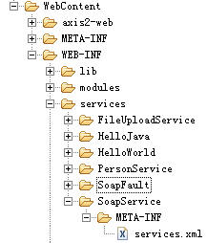

|  |
| --- |
| <service name="SoapService">           <description>                     This is the service for revoking certificate.           </description>           <parameter name="ServiceClass" locked="false">                     org.sky.axis2.soap.SoapService           </parameter>           <operation name="request">                     <messageReceiver                              class="org.apache.axis2.receivers.RawXMLINOutMessageReceiver" />                     <actionMapping>urn:request</actionMapping>           </operation>  </service> |

该Web Service接受一个Soap请求，该请求为如下格式：

|  |
| --- |
| <soapenv:Envelope xmlns:soapenv="http://schemas.xmlsoap.org/soap/envelope/" xmlns:soap="http://soap.axis2.sky.org">     <soapenv:Header/>     <soapenv:Body>        <soap:request>             <soap:request>**?**</soap:request>        </soap:request>     </soapenv:Body>  </soapenv:Envelope> |

**其中<soap:request></soap:request>中间的内容，应该如下所示：**

|  |
| --- |
| <Request xmlns="http://10.225.104.122">      <Issuer>1234567890</Issuer>      <Serial>11111111</Serial>      <RevokeDate>2007-01-01</RevokeDate>  </ Response > |

我们假设它是一个购买图书的定单，服务端收到这个请求后会返回一个定单信息给调用它的客户端，服务端将返回如下内容（此处不做任何业务处理，只是很简单的传值回客户端）。

|  |
| --- |
| <SoapResponse xmlns="http://soap.axis2.sky.org">      <Issuer>issuer: Wrox</Issuer>      <Serial>serial: 1111111111ISBN</Serial>      <RevokeDate>RevocationDate: 2012-07-29</RevokeDate>  </SoapResponse> |

为生成上述这个SoapResponse我们在Service端的核心代码如上面加粗部分的代码所示，由其注意这个“**soapResponse.build();**”。

下面我们来看这个客户端是怎么写的，我们这边用的是非阻塞式客户端

**org.sky.axis2.soap.SoapServiceClient**

|  |
| --- |
| package org.sky.axis2.soap;    import org.apache.axiom.om.OMAbstractFactory;  import org.apache.axiom.om.OMElement;  import org.apache.axiom.om.OMFactory;  import org.apache.axiom.om.OMNamespace;  import org.apache.axis2.AxisFault;  import org.apache.axis2.Constants;  import org.apache.axis2.addressing.EndpointReference;  import org.apache.axis2.client.Options;  import org.apache.axis2.client.ServiceClient;  import org.apache.axis2.client.async.AxisCallback;  import org.apache.axis2.context.MessageContext;  import javax.xml.namespace.QName;    public class SoapServiceClient {           private static EndpointReference targetEPR = new EndpointReference(                              "http://localhost:8080/Axis2Service/services/SoapService");           public static boolean finish = false;           public static void orderRequest() {                     OMFactory factory = OMAbstractFactory.getOMFactory();  **OMNamespace omNs = factory.createOMNamespace(**  **"http://soap.axis2.sky.org", "");**  **OMElement issuer = factory.createOMElement("Issuer", omNs);**  **OMElement serial = factory.createOMElement("Serial", omNs);**  **OMElement revocationDate = factory.createOMElement("RevocationDate",**  **omNs);**  **issuer.setText("Wrox");**  **serial.setText("1111111111ISBN");**  **revocationDate.setText("2012-07-29");**  **OMElement requestSoapMessage = factory.createOMElement("request", omNs);**  **requestSoapMessage.addChild(issuer);**  **requestSoapMessage.addChild(serial);**  **requestSoapMessage.addChild(revocationDate);**  **requestSoapMessage.build();**                     Options options = new Options();                     options.setTo(targetEPR);                     ServiceClient sender = null;                     try {                              AxisCallback callback = new AxisCallback() {                                       public void onMessage(MessageContext msgContext) {  **OMElement result = msgContext.getEnvelope().getBody()**  **.getFirstElement();**                                                 // System.out.println(msgContext.toString());                                                 // System.out.println(msgContext.getEnvelope().toString());  **System.out.println(msgContext.getEnvelope().getBody()**  **.getFirstElement());**  **finish = true;**                                       }                                       public void onFault(MessageContext msgContext) {                                                 System.out.println(msgContext.getEnvelope().getBody()                                                                   .getFault().toString());                                       }                                       public void onError(Exception e) {                                       }                                       public void onComplete() {                                                 System.out.println("Completed!!!");                                       }                              };                              sender = new ServiceClient();                              sender.setOptions(options);                              System.out.println("-------Invoke the service---------");                              sender.sendReceiveNonBlocking(requestSoapMessage, callback);                              synchronized (callback) {                                       if (!finish) {                                                 try {                                                          callback.wait(1000);                                                 } catch (Exception e) {                                                 }                                       }                                       if (!finish) {                                                 throw new AxisFault(                                                                   "Server was shutdown as the async response take too long to complete");                                       }                              }                     } catch (AxisFault e) {                              e.printStackTrace();                     } finally {                              if (sender != null)                                       try {                                                 sender.cleanup();                                       } catch (Exception e) {                                       }                     }             }           public static void main(String[] args) {                     orderRequest();           }  } |

上述代码和前两天的客户端代码没啥区别，我已经把核心代码用红色给标粗了。

运行后行得到输出

**客户端运行后的输出：**

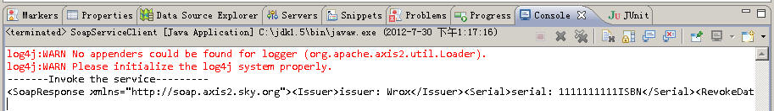

**服务端的输出：**

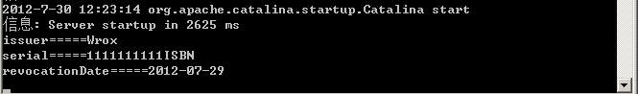

**三、服务端将Exception以SOAPFault的形式抛给客户端**

上面这个例子很简单，它展示了一个客户端向服务端发送一个request，服务端接收到客户端的Request(OMElement类型)后解析并根据相应的业务逻辑向客户端再返回一个response(OMElement类型)的完整过程。

下面我们要来看的是，如果客户端在调用服务器时发生任何错误，服务端如何把这个错误经过包装后再返回给客户端的例子。

还记得我们在非阻塞式客户端中有如下这样的触发器吗？

|  |
| --- |
| public void onMessage(MessageContext msgContext) {  }  public void onFault(MessageContext msgContext) {  }  public void onError(Exception e) {  }  public void onComplete() {  } |

此处的onFault就是用于接受从服务端抛过来的Exception的，我们把它称为SOAPFault。

下面来看一个例子，先来看Service端

**org.sky.axis2.soap.SoapFaultService**

|  |
| --- |
| package org.sky.axis2.soap;    import org.apache.axiom.om.OMAbstractFactory;  import org.apache.axiom.om.OMElement;  import org.apache.axiom.om.OMFactory;  import org.apache.axiom.om.OMNamespace;  import org.apache.axiom.soap.SOAPFactory;  import org.apache.axiom.soap.SOAPFault;  import org.apache.axiom.soap.SOAPFaultCode;  import org.apache.axiom.soap.SOAPFaultReason;  import org.apache.axis2.AxisFault;  import org.apache.axis2.context.MessageContext;  public class SoapFaultService {           private int i = 0;           public OMElement getPrice(OMElement request) throws AxisFault {                     if (request == null) {                              SOAPFault fault = getSOAPFault();                              return fault;                     }                     OMFactory factory = OMAbstractFactory.getOMFactory();                     OMNamespace ns = factory.createOMNamespace("", "");                     OMElement response = factory.createOMElement("Price", ns);                     response.setText(String.valueOf(i++));                     return response;           }           private SOAPFault getSOAPFault() {                     MessageContext context = MessageContext.getCurrentMessageContext();                     SOAPFactory factory = null;                     if (context.isSOAP11()) {                              factory = OMAbstractFactory.getSOAP11Factory();                     } else {                              factory = OMAbstractFactory.getSOAP12Factory();                     }  **SOAPFault fault = factory.createSOAPFault();**  **SOAPFaultCode faultCode = factory.createSOAPFaultCode(fault);**  **faultCode.setText("13");**  **factory.createSOAPFaultValue(faultCode);**  **SOAPFaultReason faultReason = factory.createSOAPFaultReason(fault);**  **faultReason.setText("request can not be null");**  **factory.createSOAPFaultText(faultReason);**  **factory.createSOAPFaultDetail(fault);**                     return fault;           }  } |

注意加粗部分的代码，由其是标成红色的代码为核心代码。

来看Service描述：

|  |
| --- |
| <service name="SoapFaultService">           <Description>                     Please Type your service description here           </Description>           <parameter name="ServiceClass" locked="false">org.sky.axis2.soap.SoapFaultService           </parameter>           <operation name="getPrice">                     <messageReceiver                              class="org.apache.axis2.receivers.RawXMLINOutMessageReceiver" />                     <actionMapping>urn:getPrice</actionMapping>           </operation>  </service> |

上述这个WebService接受一个输入的参数，如果输入的内容为空，则返回一个SoapFault，即键值为13，内容为” request can not be null”。

我们来看客户端的代码

**org.sky.axis2.soap.SoapFaultClient**

|  |
| --- |
| package org.sky.axis2.soap;  import java.util.Iterator;  import javax.xml.namespace.QName;  import org.apache.axiom.om.OMAbstractFactory;  import org.apache.axiom.om.OMElement;  import org.apache.axiom.om.OMFactory;  import org.apache.axiom.om.OMNamespace;  import org.apache.axis2.AxisFault;  import org.apache.axis2.Constants;  import org.apache.axis2.addressing.EndpointReference;  import org.apache.axis2.client.Options;  import org.apache.axis2.client.ServiceClient;  import org.apache.axis2.client.async.AxisCallback;  import org.apache.axis2.context.MessageContext;    public class SoapFaultClient {           static boolean finish = false;           public static void main(String[] args) {                     EndpointReference epr = new EndpointReference(                     "http://localhost:8080/Axis2Service/services/SoapFaultService");                     ServiceClient sender = null;                     try {                              OMFactory factory = OMAbstractFactory.getOMFactory();                              OMNamespace ns = factory.createOMNamespace(                                                 "http://soap.axis2.sky.org", "");                              OMElement request = factory.createOMElement("Price", ns);                              Options options = new Options();                              options.setAction("urn:getPrice");                              options.setTo(epr);                              options.setTransportInProtocol(Constants.TRANSPORT_HTTP);                              options.setUseSeparateListener(true);                              AxisCallback callback = new AxisCallback() {                                       public void onMessage(MessageContext msgContext) {                                                 OMElement result = msgContext.getEnvelope().getBody()                                                                   .getFirstElement();                                                 OMElement priceElement = result;                                                 System.out.println("price====" + priceElement.getText());                                                 finish = true;                                       }  **public void onFault(MessageContext msgContext) {**  **QName errorCode = new QName("faultcode");**  **QName reason = new QName("faultstring");**  **// System.out.println("on**  **// fault:"+msgContext.getEnvelope().getBody().getFault().toString());**  **OMElement fault = msgContext.getEnvelope().getBody()**  **.getFault();**  **System.out.println("ErrorCode["**  **+ fault.getFirstChildWithName(errorCode).getText()**  **+ "] caused by: "**  **+ fault.getFirstChildWithName(reason).getText());**  **}**                                         public void onError(Exception e) {                                       }                                         public void onComplete() {                                                 System.out.println("OnComplete!!!");                                       }                              };                              sender = new ServiceClient();                              sender.setOptions(options);                              sender.engageModule("addressing");                              try {                                         // sender.sendReceiveNonBlocking(request, callback);                                       sender.sendReceiveNonBlocking(null, callback);                              } catch (AxisFault e) {                                       System.out.println("Exception occur!");                                       System.out.println(e.getMessage());                              }                              synchronized (callback) {                                       if (!finish) {                                                 try {                                                          callback.wait(1000);                                                 } catch (Exception e) {                                                 }                                       }                              }                     } catch (AxisFault e) {                              e.printStackTrace();                              System.out.println(e.getMessage());                     } finally {                                try {                                       sender.cleanup();                              } catch (Exception e) {                              }                     }             }  } |

注意红色并加粗部分的代码，为了抓到服务端抛过来的SoapFault我们必须使用非阻塞式，因此我们在onFault处，进行接受服务端错误的处理。

**注意：**

**我们调用Service端时没有传入Service端所需要的request的参数：**

// sender.sendReceiveNonBlocking(request,callback);

***sender.sendReceiveNonBlocking(null,callback);***

**这将构成Service端抛出SoapFault。**

来看运行效果：

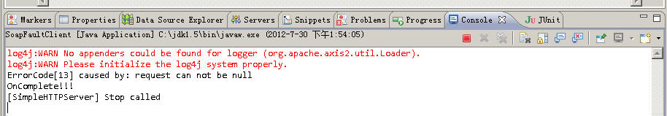

**四、使用SWA（Soap WithAttachment）来进行附件传送**

有了上面两个例子的基础后，我们将使用这个例子来结束Axis2中的Soap特性的教学。

在Axis2中传输附件有两种形式，一种叫MTOM，一种就是SWA。

SWAP即Soap With Attachment，这是业界的标准。

所谓的SWA传输，即客户端把需要上传的文件，编译成两进制代码凌晨随着soap的request一起推送到服务端，该两进制代码以AttachmentId的形式来表示，即如下这样的一个soap body：

|  |
| --- |
| <soapenv:Body>  <uploadFile xmlns="http://attachment.axis2.sky.org">  <name>test.jpg</name>  <attchmentID>**urn:uuid:8B43A26FEE1492F85A1343628038693**</attchmentID>  </uploadFile>  </soapenv:Body> |

服务端收到该soap的request可以直接使用如下的语句将这个AttachmentId还原成输出流：

|  |
| --- |
| DataHandler dataHandler = attachment.getDataHandler(attchmentID);  File file = new File(uploadFilePath.toString());  fileOutputStream = new FileOutputStream(file);  dataHandler.writeTo(fileOutputStream);  fileOutputStream.flush(); |

在我们这个例子内，我们将使用客户端上传一个jpg文件，服务端收到该jpg文件（可以是任何的两进制文件）后解析后存入服务端的一个目录。

先来看服务端代码

**org.sky.axis2.attachment.FileUploadService**

|  |
| --- |
| package org.sky.axis2.attachment;    import java.io.File;  import java.io.FileOutputStream;  import java.io.IOException;    import javax.activation.DataHandler;    import org.apache.axiom.attachments.Attachments;  import org.apache.axis2.context.MessageContext;  import org.sky.axis2.util.UUID;    public class FileUploadService {           public String uploadFile(String name, String attchmentID) throws Exception {                     FileOutputStream fileOutputStream = null;                     StringBuffer uploadFilePath = new StringBuffer();                     String fileNamePrefix = "";                     String fileName = "";                     try {  **MessageContext msgCtx = MessageContext.getCurrentMessageContext();**  **Attachments attachment = msgCtx.getAttachmentMap();**  **DataHandler dataHandler = attachment.getDataHandler(attchmentID);**  **fileNamePrefix = name.substring(name.indexOf("."), name.length());**  **fileName = UUID.getUUID();**  **System.out.println("fileName=====" + fileName);**  **System.out.println("fileNamePrefix====" + fileNamePrefix);**  **uploadFilePath.append("D:/upload/axis2/");**  **uploadFilePath.append(fileName);**  **uploadFilePath.append(fileNamePrefix);**  **System.out**  **.println("uploadFilePath====" + uploadFilePath.toString());**  **File file = new File(uploadFilePath.toString());**  **fileOutputStream = new FileOutputStream(file);**  **dataHandler.writeTo(fileOutputStream);**  **fileOutputStream.flush();**                     } catch (Exception e) {                              throw new Exception(e);                     } finally {                              try {                                       if (fileOutputStream != null) {                                                 fileOutputStream.close();                                                 fileOutputStream = null;                                       }                              } catch (Exception e) {                              }                     }                     return "File saved succesfully.";           }  } |

下面是服务端的描述

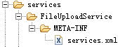

service.xml文件的内容为：

|  |
| --- |
| <service name="AttachmentService">           <parameter name="ServiceClass">org.sky.axis2.attachment.FileUploadService           </parameter>           <operation name="uploadFile">                     <actionMapping>urn:uploadFile</actionMapping>                     <messageReceiver class="org.apache.axis2.rpc.receivers.RPCMessageReceiver" />           </operation>  </service> |

该服务端接受客户端上传的附件后使用UUID重新命名上传的文件名，并将其存入服务端的” D:/upload/axis2/”目录中。

来看客户端代码

**org.sky.axis2.attachment.FileUploadClient**

|  |
| --- |
| package org.sky.axis2.attachment;    import java.io.File;    import javax.activation.DataHandler;  import javax.activation.FileDataSource;  import javax.xml.namespace.QName;    import org.apache.axiom.om.OMAbstractFactory;  import org.apache.axiom.om.OMElement;  import org.apache.axiom.om.OMNamespace;  import org.apache.axiom.soap.SOAP11Constants;  import org.apache.axiom.soap.SOAPBody;  import org.apache.axiom.soap.SOAPEnvelope;  import org.apache.axiom.soap.SOAPFactory;  import org.apache.axis2.Constants;  import org.apache.axis2.addressing.EndpointReference;  import org.apache.axis2.client.OperationClient;  import org.apache.axis2.client.Options;  import org.apache.axis2.client.ServiceClient;  import org.apache.axis2.context.ConfigurationContext;  import org.apache.axis2.context.ConfigurationContextFactory;  import org.apache.axis2.context.MessageContext;  import org.apache.axis2.wsdl.WSDLConstants;    public class FileUploadClient {           private static EndpointReference targetEPR = new EndpointReference(                              "http://localhost:8080/Axis2Service/services/AttachmentService");             public static void main(String[] args) throws Exception {                     new FileUploadClient().transferFile();           }             public void transferFile() throws Exception {                     String filePath = "D:/deployment/test.jpg";                     String destFile = "test.jpg";                     Options options = new Options();                     options.setTo(targetEPR);  **options.setProperty(Constants.Configuration.ENABLE_SWA,**  **Constants.VALUE_TRUE);**  **options.setSoapVersionURI(SOAP11Constants.SOAP_ENVELOPE_NAMESPACE_URI);**                     options.setTimeOutInMilliSeconds(10000);                     options.setTo(targetEPR);                     options.setAction("urn:uploadFile");  **ConfigurationContext configContext = ConfigurationContextFactory**  **.createConfigurationContextFromFileSystem(**  **"D:/wspace/Axis2Service/WebContent/WEB-INF/modules",**  **null);**                       ServiceClient sender = new ServiceClient(configContext, null);                     sender.setOptions(options);  **OperationClient mepClient = sender**  **.createClient(ServiceClient.ANON_OUT_IN_OP);**    **MessageContext mc = new MessageContext();**  **FileDataSource fileDataSource = new FileDataSource(new File(filePath));**                       // Create a dataHandler using the fileDataSource. Any implementation of                     // javax.activation.DataSource interface can fit here.  **DataHandler dataHandler = new DataHandler(fileDataSource);**  **String attachmentID = mc.addAttachment(dataHandler);**                       SOAPFactory fac = OMAbstractFactory.getSOAP11Factory();                     SOAPEnvelope env = fac.getDefaultEnvelope();                     OMNamespace omNs = fac.createOMNamespace(                                       "http://attachment.axis2.sky.org", "");                     OMElement uploadFile = fac.createOMElement("uploadFile", omNs);                     OMElement nameEle = fac.createOMElement("name", omNs);                     nameEle.setText(destFile);  **OMElement idEle = fac.createOMElement("attchmentID", omNs);**  **idEle.setText(attachmentID);**  **uploadFile.addChild(nameEle);**  **uploadFile.addChild(idEle);**  **env.getBody().addChild(uploadFile);**                     System.out.println("message====" + env);                     mc.setEnvelope(env);                       mepClient.addMessageContext(mc);                     mepClient.execute(true);                     MessageContext response = mepClient                                       .getMessageContext(WSDLConstants.MESSAGE_LABEL_IN_VALUE);                     SOAPBody body = response.getEnvelope().getBody();                     OMElement element = body.getFirstElement().getFirstChildWithName(                                       new QName("http://attachment.axis2.sky.org", "return"));                     System.out.println(element.getText());           }  } |

注意红色加粗部分的代码，由其是：

|  |
| --- |
| FileDataSource fileDataSource = new FileDataSource(new File(filePath));  String attachmentID = mc.addAttachment(dataHandler); |

这两句就是把客户端需要上传的附件转成AttachmentId的语句，然后把这个AttachementId作为一个OMElement的类型加入到客户端的soap request中去即可：

|  |
| --- |
| OMElement idEle = fac.createOMElement("attchmentID", omNs);  idEle.setText(attachmentID);  uploadFile.addChild(nameEle);  uploadFile.addChild(idEle);  env.getBody().addChild(uploadFile); |

来看运行效果。

客户端：

上传d:/deployment/test.jpg文件

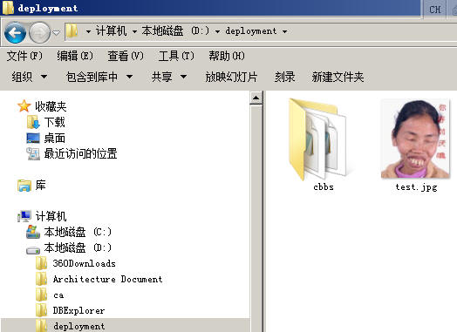

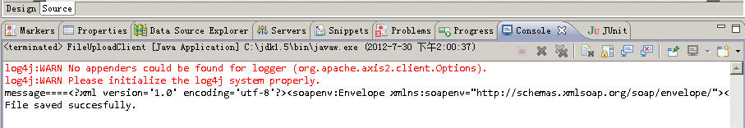

客户端收到服务端返回的”File saved successfully”即可在服务端的” D:/upload/axis2”目录中查询是否成功上传了该文件了

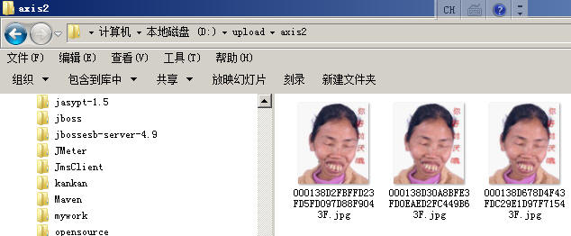

可以看到，由于我们使用的是UUID因此每次上传，服务端的文件名都不会重复。

**附录 UUID.java**

|  |
| --- |
| package org.sky.axis2.util;    public class UUID {           protected static int count = 0;             public static synchronized String getUUID() {                     count++;                     long time = System.currentTimeMillis();                       String timePattern = Long.toHexString(time);                     int leftBit = 14 - timePattern.length();                     if (leftBit > 0) {                              timePattern = "0000000000".substring(0, leftBit) + timePattern;                     }                       String uuid = timePattern                                       + Long.toHexString(Double.doubleToLongBits(Math.random()))                                       + Long.toHexString(Double.doubleToLongBits(Math.random()))                                       + "000000000000000000";                       uuid = uuid.substring(0, 32).toUpperCase();                       return uuid;           }  } |